STIIX SPEAKERS

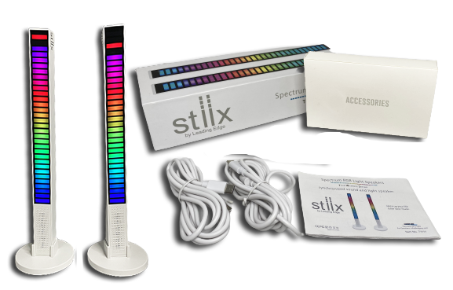

Troubleshooting

Guide

Symptoms

(Before attempting any troubleshooting, make sure speakers are fully charged)

- When speakers are turned on, music is playing in only one speaker and 2 separate STIIX connections show up on Bluetooth list

Fix by following the steps below.

- Turn OFF both speakers
- Open Smartphone device settings and click Forget / Delete STIIX name from Menu listing of Bluetooth Devices.
- Turn Bluetooth to OFF on your Smartphone.
- Turn on speakers one at a time.
- Now double click the ON/OFF button on one of the speakers and wait until you hear a beep indicating the speakers are connected. This means the TWS (Total wireless stereo) function on both speakers is now connected.
- Return to the settings option on your smartphone and turn ON the Bluetooth.
- The speaker name “ STIIX “ should appear on the list. Click to connect and the STIIX will automatically connect.
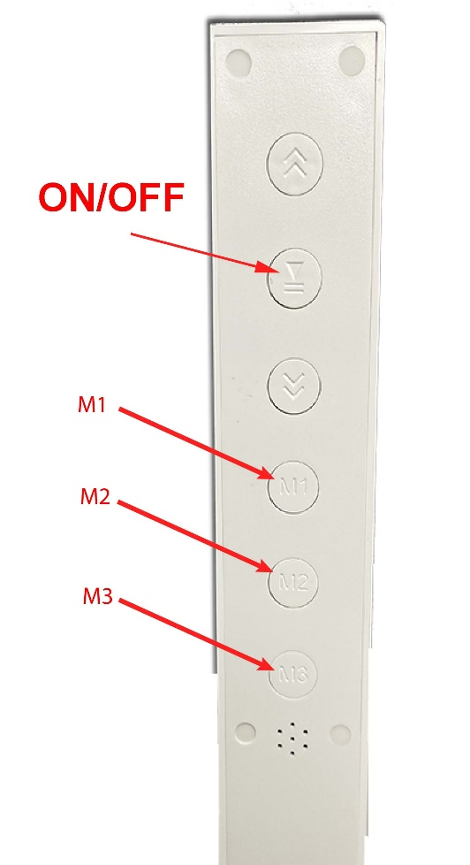
- Play the music and Enjoy !

Charging Indicator
Light

